DENSITY OF SOIL BY CORE CUTTER METHOD
Aim of the Experiment:
To determine the field or in-situ density or unit weight of soil by core cutter method
Apparatus Required:
- Special:
- Cylindrical core cutter
- Steel rammer
- Steel dolly
- General:
- Balance of capacity5 Kg and sensitivity 1 gm.
- Balance of capacity 200gms and sensitivity 0.01 gms.
- Scale
- Spade or pickaxe or crowbar
- Trimming Knife
- Oven
- Water content containers
- Desiccator.
Theory:
Field density is defined as weight of unit volume of soil present in site. That is
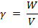
Where, Density of soil
W = Total weight of soil
V = Total volume of soil
The soil weight consists of three phase system that is solids, water and air. The voids may be filled up with both water and air, or only with air, or only with water. Consequently the soil may be dry, saturated or partially saturated.
In soils, mass of air is considered to be negligible, and therefore the saturated density is maximum, dry density is minimum and wet density is in between the two.
Dry density of the soil is calculated by using equation,
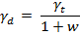
Where, dry density of soil
Wet density of soil
w = moisture content of soil.
Density or unit weight of soils may be determined by using the following method:
- Core cutter method
- Sand replacement test
- Rubber balloon test
- Water displacement method
- Gamma ray method

Hear we use core cutter method, the equipment arrangement is shown as fallows,
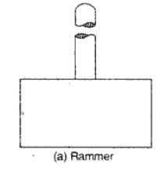
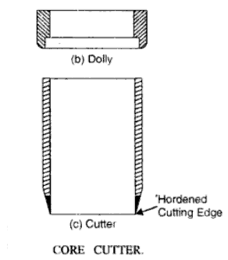
Application:
Field density is used in calculating the stress in the soil due to its overburden pressure it is needed in estimating the bearing capacity of soil foundation system, settlement of footing earth pressures behind the retaining walls and embankments. Stability of natural slopes, dams, embankments and cuts is checked with the help of density of those soils. It is the density that controls the field compaction of soils. Permeability of soils depends upon its density. Relative density of cohesionless soils is determined by knowing the dry density of soil in natural, loosest and densest states. Void ratio, porosity and degree of saturation need the help of density of soil.
Core cutter method in particular, is suitable for soft to medium cohesive soils, in which the cutter can be driven. It is not possible to drive the cutter into hard, boulder or murrumy soils. In such case other methods are adopted.
Procedure:
- Measure the height and internal diameter of the core cutter.
- Weight the clean core cutter.
- Clean and level the ground where the density is to be determined.
- Press the cylindrical cutter into the soil to its full depth with the help of steel rammer.
- Remove the soil around the cutter by spade.
- Lift up the cutter.
- Trim the top and bottom surfaces of the sample carefully.
- Clean the outside surface of the cutter.
- Weight the core cutter with the soil.
- Remove the soil core from the cutter and take the representative sample in the water content containers to determine the moisture content
Precautions:
- Steel dolly should be placed on the top of the cutter before ramming it down into the ground.
- Core cutter should not be used for gravels, boulders or any hard ground.
- Before removing the cutter, soil should be removed around the cutter to minimize the disturbances.
- While lifting the cutter, no soil should drop down

Observation and Calculation Table:
Internal diameter of cutter (cm): _ _ _ _ _ _ _ _
Height of the cutter (cm): _ _ _ _ _ _ _ _
Cross sectional area of the cutter (cm2): _ _ _ _ _ _ _ _
Volume of the cutter, V (cm3): _ _ _ _ _ _ _ _

Water/Moisture content determination:
 | sample 1 | sample 2 | sample 3
Weight of can, W₁ (g)
Weight of can + wet soil W₂ (g)
Weight of can + dry soil W₃ (g)
Water/Moisture content

Calculation Table:
 | sample 1 | sample 2 | sample 3
Mass of core cutter, W₁ (gm)
Mass of cutter + soil from field, W₂ (gm)
Wet density, (gm/cm3)
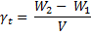
Dry density , (gm/cm3)
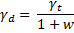

QUESTIONNAIRE:
- Out of wet density, dry density, and saturated density, which one of them is maximum and minimum? Explain.
- What are the main factors which affect in-situ density of soil? Explain.
- Beside the density what other properties do you need to calculate the void ratio and degree of saturation of soils?
- What are the other methods to calculate the field density of soil?

